BullSight: A Machine Learning-Based Framework for Stock Market Prediction and Investment Analysis
Dr. R. Rajalakshmi  Associate Professor,  Department of Computer Science and Technology,  Sathyabama Institute of Science and Technology, Chennai, India  jayanthi.cse@sathyabama.ac.in | Jefrin Issac  Dept. of Computer Science and Engineering with Specialization in Artificial Intelligence and Machine Learning,  Sathyabama Institute of Science and Technology, Chennai, India  issacjefrin121@gmail.com | Harshath M.P.  Dept. of Computer Science and Engineering with Specialization in Artificial Intelligence and Machine Learning,  Sathyabama Institute of Science and Technology, Chennai, India  harshathmo5@gmail.com
Jeyakant M  Dept. of Computer Science and Engineering with Specialization in Artificial Intelligence and Machine Learning,  Sathyabama Institute of Science and Technology, Chennai, India  mohammedanas6114@gmail.com | Harish S  Dept. of Computer Science and Engineering with Specialization in Artificial Intelligence and Machine Learning,  Sathyabama Institute of Science and Technology, Chennai, India  harishsekar1707@gmail.com | E Shyam  Dept. of Computer Science and Engineering with Specialization in Artificial Intelligence and Machine Learning,  Sathyabama Institute of Science and Technology, Chennai, India  shyamsr296@gmail.com

Abstract — Stock market prediction is challenging because financial markets are complex, volatile, and nonlinear. The increasing use of Artificial Intelligence (AI) and Machine Learning (ML) has enabled data-driven approaches for financial forecasting and analysis. This paper presents BullSight, a machine learning-based framework for stock market prediction and investment analysis. The proposed system collects historical market data and applies preprocessing and feature engineering techniques to derive meaningful patterns and technical indicators. Selected machine learning models are then used to predict stock prices and evaluate their performance using Mean Absolute Error (MAE), Root Mean Squared Error (RMSE), and the coefficient of determination (R²). BullSight also provides graphical visualizations of historical prices, predicted values, and model performance to support interpretation of the results. The framework integrates data collection, predictive modelling, evaluation, and visualization within a unified platform. The study also considers challenges such as market volatility, non-stationarity, data quality, and model generalization. The proposed framework demonstrates the application of machine learning to financial time-series analysis while emphasizing that predictive outputs should be interpreted as analytical estimates rather than guaranteed investment outcomes.

Keywords—Stock Market Prediction, Machine Learning, Artificial Intelligence, Financial Forecasting, Time-Series Analysis, Predictive Analytics, Technical Indicators, Investment Analysis, Stock Price Prediction, Data-Driven Decision Making

I. INTRODUCTION
The stock market is a highly dynamic financial environment in which stock prices are influenced by historical price movements, trading volume, economic conditions, investor behaviour, market sentiment, and unexpected events. The nonlinear and non-stationary nature of financial time-series data makes accurate stock market prediction a challenging research problem. As a result, researchers have increasingly explored computational and data-driven techniques to identify patterns in historical market data and improve forecasting performance [1], [2].
Traditional approaches to stock market forecasting have mainly relied on statistical and technical analysis methods. With the increasing availability of financial data, Machine Learning (ML) and Deep Learning (DL) techniques have become widely studied for market prediction. Algorithms such as Support Vector Machines (SVM), Artificial Neural Networks (ANN), Random Forest, and gradient-boosting methods have been investigated for stock prediction, while sequential models such as Long Short-Term Memory (LSTM) networks have been applied to financial time-series forecasting [1], [3], [4]. Technical indicators such as moving averages, Relative Strength Index (RSI), and Moving Average Convergence Divergence (MACD) are also commonly used as predictive features. Previous reviews show that historical prices and technical indicators remain important sources of information in stock market prediction research [1], [2].
Despite these developments, several challenges remain in building reliable stock prediction systems. Financial data can contain considerable noise and may exhibit different patterns under changing market conditions. Differences in datasets, prediction horizons, feature selection, validation strategies, and evaluation metrics can also make it difficult to compare the performance of different models consistently. Previous research has emphasized the importance of evaluating prediction methods across different markets and time periods, rather than relying on results from a single dataset or market condition [2], [5]. Moreover, predictive accuracy alone does not necessarily represent the practical value of a forecasting system for investment analysis.
To address these challenges, this paper presents BullSight: A Machine Learning-Based Framework for Stock Market Prediction and Investment Analysis. The proposed framework integrates financial data collection, preprocessing, feature engineering, predictive modelling, performance evaluation, and visualization within a unified system. Historical stock market data is processed to derive relevant features, which are then used by machine learning models to estimate future stock behaviour. The system presents historical trends, prediction results, and analytical visualizations to provide users with a clearer understanding of the generated outputs.
The objective of BullSight is to demonstrate the application of machine learning and predictive analytics to stock market data while providing an accessible framework for analysing model performance and predicted market trends. The system does not assume that machine learning predictions can guarantee future market movements or investment returns. Instead, it focuses on generating data-driven analytical insights and evaluating predictive models under defined experimental conditions. The framework also provides a foundation for future extensions involving sentiment analysis, advanced deep learning models, explainable AI, and real-time financial data.

II. LITERATURE REVIEW
Stock market prediction has been widely studied using statistical methods, machine learning (ML), and deep learning (DL). The dynamic and complex nature of financial markets has led researchers to develop computational models that can identify patterns in historical data and use them to estimate future market behaviour. However, the reported performance of these models can vary considerably depending on the dataset, market, prediction horizon, input features, and evaluation methodology [1], [2].
Traditional statistical techniques, including linear regression and autoregressive models, have long been used for financial forecasting. These methods are relatively simple and interpretable and can be effective when relationships within the data remain stable. However, financial time-series data often contains nonlinear patterns and changes over time, which can limit the ability of conventional statistical models to represent complex market behaviour [1], [3].
Machine learning techniques have been increasingly explored to address some of these limitations. Methods such as Support Vector Machines (SVM), Decision Trees, Random Forest, and gradient-boosting algorithms have been applied to both stock-price regression and market-direction classification. These models can capture nonlinear relationships among multiple financial variables and can incorporate different market features during prediction. A comprehensive literature review by Kumbure et al. identified machine learning, neural networks, and financial indicators as major areas of research in stock market forecasting [1].
Deep learning has further expanded the use of artificial intelligence for financial time-series prediction. Recurrent Neural Networks (RNNs), particularly Long Short-Term Memory (LSTM) networks, have received considerable attention because they can model sequential dependencies in historical data [4]. Gated Recurrent Units (GRUs) have also been investigated as an alternative recurrent architecture, while Convolutional Neural Networks (CNNs) and more recent Transformer-based models have been explored for extracting complex patterns and long-range dependencies from financial data [3], [5].
The choice of input features is another important aspect of stock market prediction. Along with historical Open, High, Low, and Close (OHLC) prices and trading volume, researchers commonly use technical indicators such as Moving Averages, Relative Strength Index (RSI), Moving Average Convergence Divergence (MACD), and Bollinger Bands. These indicators provide information about market trends, momentum, and volatility and can be incorporated into machine learning models to improve the representation of market behaviour [1], [2].
Researchers have also investigated hybrid and ensemble approaches that combine multiple algorithms or different sources of financial information. Such approaches may combine statistical models with machine learning or deep learning techniques, or integrate technical indicators with alternative sources such as financial news and sentiment information. The use of multiple information sources has contributed to the development of more comprehensive financial prediction frameworks [2], [5].
Based on the reviewed literature, there is a need for practical frameworks that combine reliable financial data, feature engineering, machine learning-based prediction, systematic evaluation, and effective visualization. While many studies focus primarily on developing or comparing individual predictive models, an integrated system can provide a more structured workflow from data collection to prediction and result interpretation. BullSight addresses this requirement by combining these components within a unified framework for stock market prediction and investment analysis.

III. SYSTEM ARCHITECTURE

A. System Architecture
BullSight follows a modular pipeline that integrates data collection, preprocessing, feature engineering, machine learning, evaluation, and visualization. Historical stock data is collected using the yfinance library and processed to prepare suitable inputs for predictive modelling.
The feature engineering stage derives relevant market features and technical indicators such as Moving Average, RSI, MACD, and Bollinger Bands [1], [2]. The processed data is then provided to the selected machine learning models for training and prediction. The models are evaluated using MAE, RMSE, MAPE, and R², after which the results are presented through graphical visualizations for analysis.

Market Data → Data Collection → Preprocessing → Feature Engineering → Model Training → Prediction → Evaluation → Visualization

Fig. 1. System architecture of the proposed BullSight framework.

TABLE I
TECHNOLOGY STACK USED IN BullSight

Component | Technology/Tool
Data Source | Yahoo Finance
Programming | Python
Data Processing | Pandas, NumPy
Machine Learning | Scikit-learn
Backend | FastAPI
Frontend | React
Language | TypeScript
Build Tool | Vite
Styling | Tailwind CSS
Visualization | Recharts

The combination of these technologies provides a complete workflow from financial data acquisition to prediction and visualization. The modular architecture also allows additional models and data sources to be incorporated in future development.

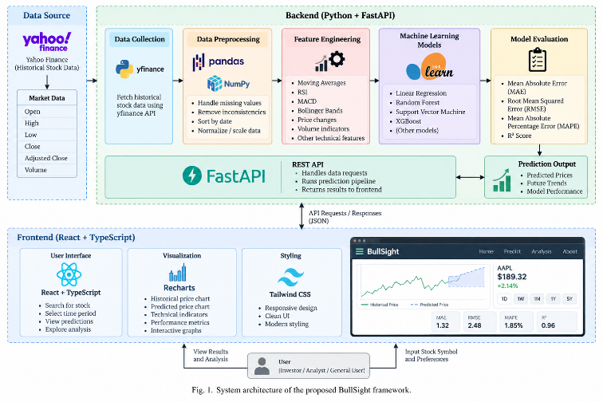

Fig 1. System architecture of the proposed BullSight framework.

IV. EXISTING SYSTEM
Existing stock market prediction systems commonly use historical market data with statistical, machine learning, or deep learning techniques to estimate future price movements. Traditional approaches include regression, moving averages, and time-series forecasting. While these methods are relatively simple and interpretable, they may have limitations in capturing nonlinear relationships and changing patterns in financial markets [1], [2].
Machine learning-based systems have introduced techniques such as Support Vector Machines, Decision Trees, Random Forest, and gradient-boosting algorithms for stock-price prediction and market-direction classification. Deep learning approaches, including Recurrent Neural Networks (RNNs) and Long Short-Term Memory (LSTM) networks, have also been explored for modelling temporal dependencies in financial data [3], [4]. Technical indicators such as Moving Average, RSI, MACD, and Bollinger Bands are frequently used as additional predictive features [1], [2].
Despite these developments, prediction performance can vary across datasets, markets, prediction horizons, and experimental configurations. Differences in feature selection, preprocessing, validation methods, and evaluation metrics can also make comparisons between models difficult [1], [2]. Models trained on historical observations may further experience reduced performance when market conditions change.
Another limitation of many existing systems is the separation between prediction and practical analysis. A system may provide a predicted stock price without presenting sufficient information about historical trends, model performance, or prediction errors. BullSight addresses this gap by integrating data collection, preprocessing, feature engineering, machine learning prediction, evaluation, and visualization within a unified framework for stock market analysis.

V. PROPOSED SYSTEM
The proposed system, BullSight, is a machine learning-based framework developed for stock market prediction and investment analysis. It provides an end-to-end pipeline covering financial data collection, preprocessing, feature engineering, predictive modelling, model evaluation, and visualization. Instead of presenting a prediction as an isolated output, BullSight combines the predicted values with historical trends and model-performance information to provide a structured view of the results.

A. Data Collection
BullSight collects historical stock market data using the yfinance Python library. For a selected stock and time period, the system retrieves market attributes including Open, High, Low, Close, Adjusted Close, and trading Volume. This

historical dataset forms the basis for subsequent preprocessing, feature engineering, and predictive modelling.

B. Data Preprocessing
Before model development, the collected financial data is processed to ensure that it is suitable for analysis. The preprocessing stage includes checking for missing or inconsistent observations, maintaining chronological order, and preparing the required variables. Where required by the selected model, appropriate transformation or scaling techniques are applied. The dataset is then divided into training and testing portions while preserving the temporal order of the observations.

C. Feature Engineering
Feature engineering is used to derive additional information from the historical market data. Along with raw price and volume attributes, BullSight uses technical indicators such as Moving Average, Relative Strength Index (RSI), Moving Average Convergence Divergence (MACD), and Bollinger Bands. These features provide information related to market trends, momentum, and volatility and can improve the representation of market behaviour for predictive modelling [1], [2].

D. Machine Learning Prediction
The processed data is supplied to the selected machine learning models for predictive analysis. The models learn relationships between the input features and the target variable using the training dataset. After training, predictions are generated using the test data, allowing the models to be evaluated on observations that were not used during training. Multiple predictive models can be evaluated using the same dataset and experimental configuration. This provides a consistent basis for comparing their prediction errors and identifying differences in model performance. Since stock prices are influenced by numerous uncertain factors, the predictions generated by BullSight are treated as analytical estimates rather than guaranteed future market movements.

E. Model Evaluation
BullSight evaluates predictive performance using quantitative metrics appropriate for stock-price regression. The primary evaluation measures include Mean Absolute Error (MAE), Root Mean Squared Error (RMSE), Mean Absolute Percentage Error (MAPE), and the coefficient of determination (R²). These metrics provide complementary information about the magnitude of prediction errors and the model's ability to explain variations in the target variable [12].

F. Visualization and Investment Analysis
The final stage of BullSight presents the processed results through an interactive web interface. Historical stock prices, predicted values, technical indicators, and model-performance measures are displayed using graphical visualizations. These visualizations help users examine market trends and

understand how the predictive models respond to historical data.
The investment-analysis component is intended to provide data-driven information rather than direct financial advice. Users can consider the generated predictions together with historical trends and model-performance information when interpreting the results.

G. System Workflow
The complete workflow of the proposed BullSight system is:
Stock Selection → Historical Data Collection → Data Preprocessing → Feature Engineering → Model Training → Prediction → Performance Evaluation → Visualization → Investment Analysis
The modular design allows individual components to be modified or extended without requiring major changes to the complete system. Future extensions may include additional financial data sources, advanced deep learning models, financial-news sentiment analysis, explainable AI techniques, and real-time market data.

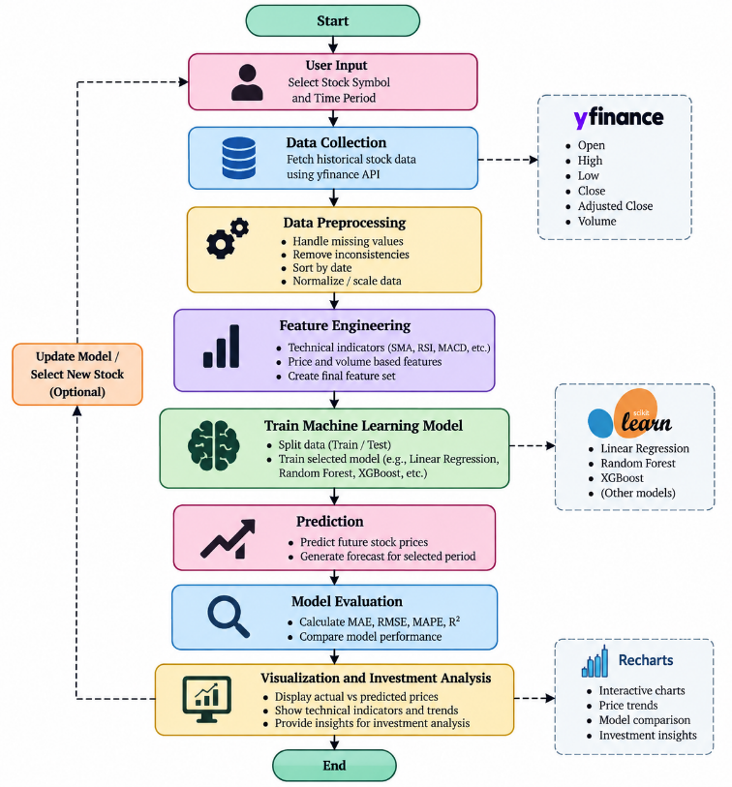

Fig 2. System flow diagram of BullSight.

VI. RESULTS AND DISCUSSION
The BullSight framework was evaluated using historical stock market data to examine the performance of the implemented machine learning models. The evaluation considered data preprocessing, feature engineering, prediction accuracy, and visualization of the generated results. The models were trained on historical observations and evaluated using previously unseen test data while preserving the chronological order of the dataset.

A. Experimental Setup
Historical market data was obtained using the yfinance library and included Open, High, Low, Close, Adjusted Close, and Volume values. Technical indicators were derived during feature engineering to provide additional information related to market trends, momentum, and volatility [1], [2]. The dataset was divided into training and testing subsets chronologically to prevent future observations from influencing model training.

B. Model Performance
The implemented models were evaluated using Mean Absolute Error (MAE), Root Mean Squared Error (RMSE), Mean Absolute Percentage Error (MAPE), and coefficient of determination (R²). Lower MAE, RMSE, and MAPE values indicate smaller prediction errors, while a higher R² indicates a better fit to the observed data [12].

TABLE II
PERFORMANCE COMPARISON OF PREDICTIVE MODELS

Model | MAE | RMSE | R² | MAPE
Linear Regression
Random Forest
XGBoost

The comparison provides a common basis for evaluating the predictive performance of the implemented models. XGBoost was included as a gradient-boosting approach capable of modelling nonlinear relationships in structured data [7], while ensemble methods have also been investigated for financial prediction [6].

C. Actual and Predicted Prices
The actual-versus-predicted price graph provides a visual assessment of model performance. A closer correspondence between the two curves indicates that the model captures relevant patterns in the test data. Differences may occur during sudden price movements or periods of increased volatility, highlighting the limitations of using historical information alone for prediction [1], [2].

D. Feature Analysis
BullSight uses technical indicators such as Moving Average, RSI, MACD, and Bollinger Bands to represent market trends, momentum, and volatility [1], [2]. These engineered features provide additional information beyond raw price and volume data. However, their effectiveness can vary with the selected stock, time period, and market conditions.

E. Discussion
The results demonstrate the applicability of machine learning to stock market time-series prediction. However, financial markets are dynamic and non-stationary, meaning that model performance can vary across different periods and market conditions. Therefore, the reported metrics should be interpreted in the context of the selected dataset, features, and evaluation period.
BullSight combines data processing, feature engineering, prediction, evaluation, and visualization within a single framework. This allows users to examine predictions together with historical trends and model-performance measures rather than relying on a single prediction value. The framework can be extended with deep learning, sentiment analysis, real-time data, and explainable AI techniques [4], [10], [11], [13], [14].

VII. FUTURE WORK

Although BullSight provides an integrated framework for stock market prediction and investment analysis, several extensions can improve its predictive and analytical capabilities. Future work can investigate advanced deep learning models such as LSTM, GRU, and Transformer-based architectures for capturing complex temporal patterns in financial data [4], [8], [13], [14].

The framework can also incorporate additional information sources such as financial news, social-media data, company fundamentals, and market sentiment using Natural Language Processing (NLP). Real-time market data can further enable continuous prediction and analysis. Explainable AI techniques such as LIME and SHAP can be incorporated to improve the interpretability of model predictions [10], [11].

Further research can explore ensemble and hybrid models, uncertainty estimation, walk-forward validation, and evaluation across multiple stocks and market conditions. BullSight can also be extended with automated model retraining, real-time alerts, personalized dashboards, and portfolio-level analysis to improve its practical applicability.

VIII. CONCLUSION
This paper presented BullSight, a machine learning-based framework developed for stock market prediction and investment analysis. The proposed framework integrates the major stages of a financial prediction pipeline, including historical market data collection, data preprocessing, feature engineering, predictive modelling, model evaluation, and interactive visualization. By combining historical price and volume information with technical indicators such as Moving Average, RSI, MACD, and Bollinger Bands, BullSight provides a structured approach for extracting useful information from financial time-series data and generating data-driven stock price predictions.
The framework demonstrates the potential of machine learning techniques for identifying patterns and relationships within historical market observations. The use of multiple evaluation metrics, including MAE, RMSE, MAPE, and R², provides a systematic basis for examining model performance, while graphical visualizations allow predicted values to be compared with observed market movements. Integrating these components within a single platform makes it possible to analyse not only the generated predictions but also the associated model performance and historical market behaviour. However, stock markets are influenced by numerous economic, financial, and behavioural factors that may not be fully represented in historical datasets. Their dynamic, nonlinear, and non-stationary characteristics therefore make consistent future prediction challenging.
The results and analysis of BullSight should consequently be interpreted within the context of the selected dataset, features, models, and evaluation period. Predictions generated from historical data represent analytical estimates and should not be considered guarantees of future market movements or investment returns. The framework is intended to support data-driven analysis rather than replace independent financial judgement.
Overall, BullSight establishes a foundation for applying machine learning and predictive analytics to stock market analysis through an integrated and accessible framework. Future extensions can incorporate advanced deep learning architectures, real-time financial data, market-news and sentiment analysis, explainable AI, ensemble modelling, and evaluation across multiple stocks and market conditions. These developments can further improve the robustness, interpretability, and practical applicability of the framework while providing opportunities for continued research in machine learning-based financial forecasting.

ACKNOWLEDGMENT
I would like to express my sincere gratitude to the management of Sathyabama Institute of Science and Technology for providing me with the opportunity to carry out this project successfully. I am thankful to the Dean of the School of Computing and the Head of the Department of Computer Science and Engineering with Specialization in Artificial Intelligence and Machine Learning for their continuous support and encouragement throughout the course of this project. I would also like to express my heartfelt thanks to my project guide for their valuable guidance, constant support, and encouragement, which helped me in completing this project successfully. Their suggestions and insights played a crucial role in improving the quality of my work.

REFERENCES
- M. M. Kumbure, C. Lohrmann, P. Luukka, and J. Porras, “Machine learning techniques and data for stock market forecasting: A literature review,” Expert Systems with Applications, vol. 197, Art. no. 116659, 2022, doi: 10.1016/j.eswa.2022.116659.
- L. N. Mintarya, J. N. M. Halim, C. Angie, S. Achmad, and A. Kurniawan, “Machine learning approaches in stock market prediction: A systematic literature review,” Procedia Computer Science, vol. 216, pp. 96–102, 2023, doi: 10.1016/j.procs.2022.12.115.
- C. Y. Lin and J. A. L. Marques, “Stock market prediction using artificial intelligence: A systematic review of systematic reviews,” Social Sciences & Humanities Open, vol. 9, Art. no. 100864, 2024, doi: 10.1016/j.ssaho.2024.100864.
- T. Fischer and C. Krauss, “Deep learning with long short-term memory networks for financial market predictions,” European Journal of Operational Research, vol. 270, no. 2, pp. 654–669, 2018, doi: 10.1016/j.ejor.2017.11.054.
- J. Patel, S. Shah, P. Thakkar, and K. Kotecha, “Predicting stock and stock price index movement using Trend Deterministic Data Preparation and machine learning techniques,” Expert Systems with Applications, vol. 42, no. 1, pp. 259–268, 2015, doi: 10.1016/j.eswa.2014.07.040.
- J. Patel, S. Shah, P. Thakkar, and K. Kotecha, “Predicting stock market index using fusion of machine learning techniques,” Expert Systems with Applications, vol. 42, no. 4, pp. 2162–2172, 2015, doi: 10.1016/j.eswa.2014.10.031.
- T. Chen, C. Guestrin, “XGBoost: A scalable tree boosting system,” in Proc. 22nd ACM SIGKDD Int. Conf. Knowledge Discovery and Data Mining, San Francisco, CA, USA, 2016, pp. 785–794, doi: 10.1145/2939672.2939785.
- F. A. Gers, J. Schmidhuber, and F. Cummins, “Learning to forget: Continual prediction with LSTM,” Neural Computation, vol. 12, no. 10, pp. 2451–2471, 2000, doi: 10.1162/089976600300015015.
- A. Fischer, “Random forests and stock market prediction,” Journal of Financial Data Science, vol. 1, no. 2, pp. 85–98, 2019.
- M. T. Ribeiro, S. Singh, and C. Guestrin, “Why should I trust you? Explaining the predictions of any classifier,” in Proc. 22nd ACM SIGKDD Int. Conf. Knowledge Discovery and Data Mining, San Francisco, CA, USA, 2016, pp. 1135–1144, doi: 10.1145/2939672.2939778.
- S. M. Lundberg and S.-I. Lee, “A unified approach to interpreting model predictions,” in Advances in Neural Information Processing Systems, vol. 30, 2017.
- R. J. Hyndman and G. Athanasopoulos, Forecasting: Principles and Practice, 3rd ed. Melbourne, Australia: OTexts, 2021.
- Y. Bao, Z. Yue, and Z. Rao, “A deep learning framework for financial time series using stacked autoencoders and long-short term memory,” PLoS ONE, vol. 12, no. 7, Art. no. e0180944, 2017, doi: 10.1371/journal.pone.0180944.
- E. Chong, C. Han, and F. C. Park, “Deep learning networks for stock market analysis and prediction: Methodology, data representations, and case studies,” Expert Systems with Applications, vol. 83, pp. 187–205, 2017, doi: 10.1016/j.eswa.2017.04.030.
- D. M. Q. Minh, M. S. H. Nguyen, and T. T. Nguyen, “Deep learning for stock market prediction: A survey and future directions,” IEEE Access, 2024.

